**Aim:**

To design and deploy a simple Flight Reservation System on a cloud platform (Zoho Creator) using a single reservation form, thereby demonstrating Software as a Service (SaaS).

**Procedure:**

1. **Login to Zoho Creator**
   * Open Zoho Creator and sign in with your Zoho account.
2. **Create a New Application**
   * Click **Create Application → From Scratch**.
   * Name it: **Flight Reservation System**.
3. **Design the Reservation Form**  
   Create a single form named **Flight Reservation Form** with the following fields:
   * **Reservation ID** (Auto-generated)
   * **Passenger Name** (Text)
   * **Age** (Number)
   * **Gender** (Dropdown: Male, Female, Other)
   * **Contact Number** (Phone)
   * **Email ID** (Email)
   * **Flight Number** (Text / Dropdown)
   * **Source Airport** (Dropdown)
   * **Destination Airport** (Dropdown)
   * **Date of Journey** (Date Picker)
   * **Seat Class** (Dropdown: Economy, Business, First Class)
4. **Create Report (View)**
   * Add a report table **Reservation List** to display all bookings.
   * Allow search and filters by **Passenger Name, Flight Number, or Date**.
5. **Add Workflow (Optional)**
   * Use Deluge script to send an **email confirmation** to the passenger after booking.

**Flight Ticket Reservations:**

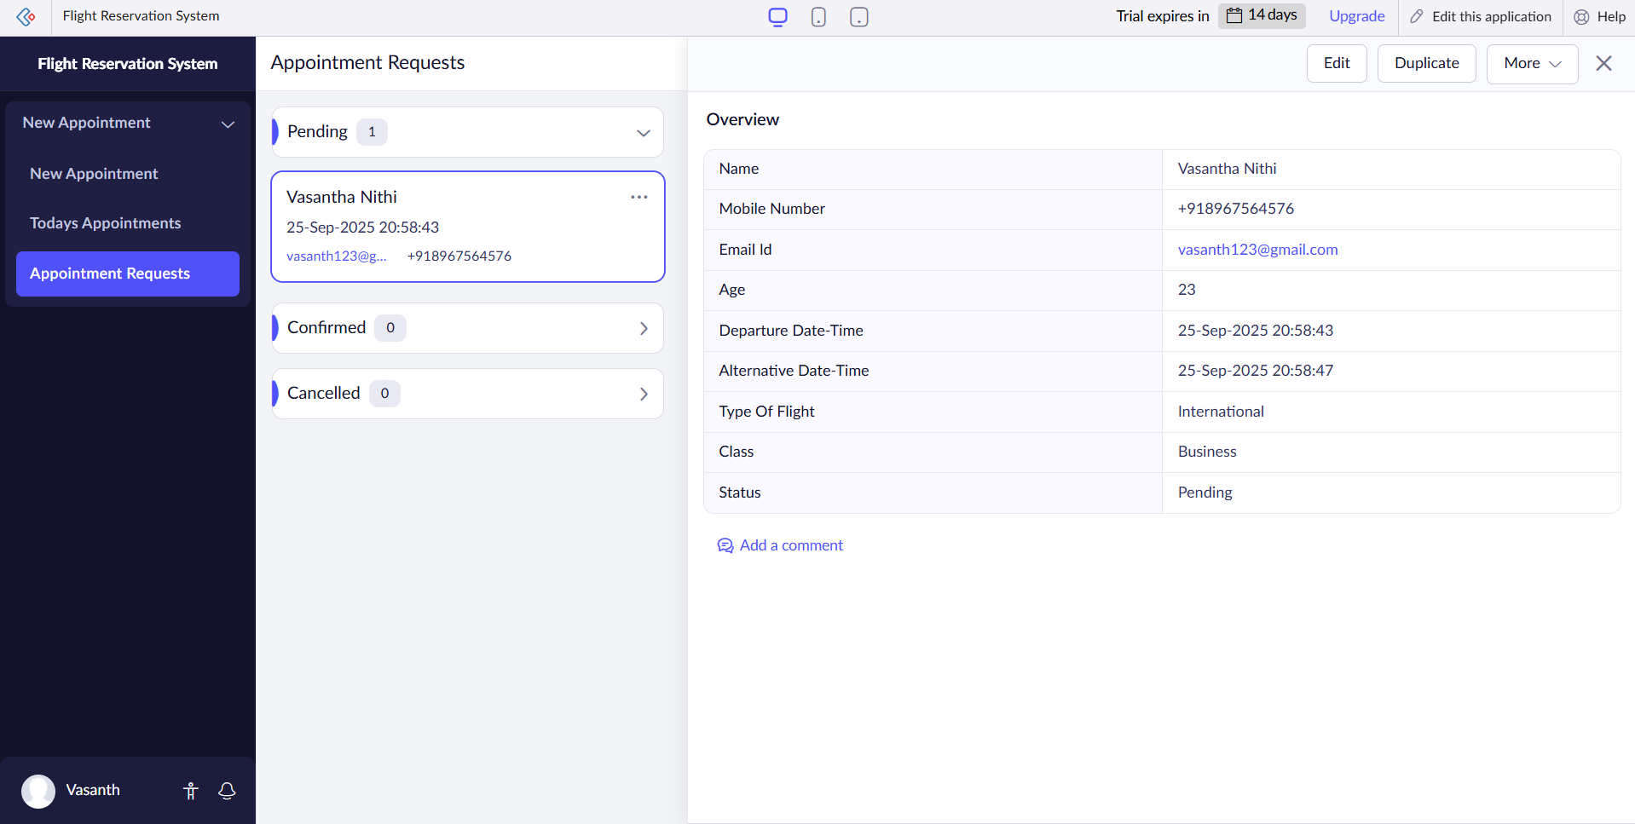

**Result:**

* A **Flight Reservation System** was successfully created and deployed on Zoho Creator.
* Passengers can enter their details and book flight tickets using the form.
* Reservations are stored in the cloud and can be accessed anytime through Zoho Creator.
* The system demonstrates the concept of **Software as a Service (SaaS)** by providing a cloud-based, globally accessible flight booking application.